(Approx. 755 words)

Prepare for Hard Drive Recovery
by Bob Hudak, Greater South Bay User Group Hardware SIG Leader (California)
http://gsbug.apcug.org
uags(at)aol.com

Obtained from APCUG with the author's permission for publication by APCUG member groups.

When you lose control of your computer due to a virus or some sort of malware, or your O.S. becomes corrupted for one reason or another, be ready to fix the problem.

1. Start by setting up your hard drive with 2 partitions at least. Put all programs on ‘C:’ & all Data on ‘D:’

2. When hard drive is clean and all programs are loaded, it is time to make an image file of ‘C:.’ Use Acronis True Image to do this

or whatever program you like. Put it on ‘D:’ drive in the root. Name it using date. Remember you do not have a backup till you have two copies in two different places. So now copy this image file to an external USB drive.
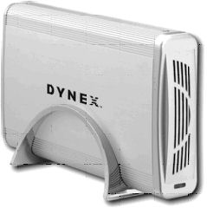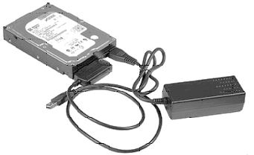

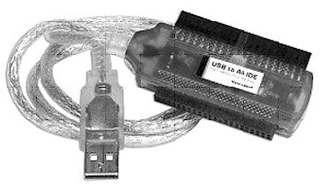
The reason is if ‘‘C:’ goes bad you can reformat it and start over without losing any data. If your computer will not boot and you did not put all your data on another drive or partition, you will want to save your data before reinstalling your operating system. What can you do?

A. Open computer case and remove drive. Install drive as a slave drive in another computer. Now you can copy and paste your data or burn to a CD. This means opening two computers and moving the drive in and out and resetting the jumpers.

B. Hook up the drive you removed from your computer to a second computer using a USB adapter, like the one we have at the Hardware SIG, to another computer and copy and paste or burn the data you want to keep.

C. Here is my first choice in a case like this. Use a Live Linux CD to boot up. Plug in a USB drive before booting. After booting, mount your ‘C:’ drive and your USB drive. Copy your data from ‘C:’ drive to the USB drive. With this option there is no case to open and drive to
remove.

3. Backup your data as necessary to a CD or another drive. Use a USB drive. This drive can also fail so putting backup on a CD or DVD is better way to go. Also, there is an on-line service at Carbinite.com that will automatically back up your data. This service costs $50.00 a year for unlimited backups. How important is your data?

Here are a few key folders to have on ‘D:’’ drive:

Data — In this folder make sub folders for each application you use. Include one called Pictures. Under this folder have another sub folders for different events. Like: Christmas07, Vacation08, Dog, etc.

D/L — Use this folder for all your downloads. Then you will always know where your down-loads are. Set it up so the last thing you downloaded is on top.

E-Mail. If possible. You wanted your e-mail off the ‘C’ drive

My Stuff. Cut and paste from ‘My Documents’ on ‘C’ items that were sent there without asking you where to send. Documents that you want to keep.

Using Acronis True Image

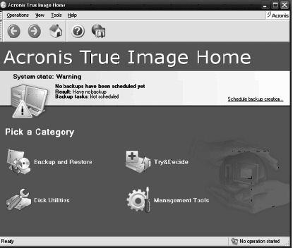

Use Acronis True Image to backup to your USB drive. Make a full backup the first time.

This is going to be pretty easy because all your data is in one folder on ‘D:’ called DATA. If you want to backup your downloaded items, back up the ‘D/L’’ folder. E-Mail is not something I backup but you may want to. Once again it should all be in the ‘E-MAIL’ folder.

You already loaded the Acronis program and made a rescue CD that is bootable. Right?

Now open your CD drive and insert the CD. Do not close the drive. Shut down your computer. Close the CD drive. Wait a minute and then reboot.

If you have your BIOS set to boot from a CD first, you are good to go. If not you will need to enter into your setup screen at boot-up and change the boot order.

After booting up with Acronis, follow the prompts to select what you want backed up. Practice this before you need to use it.
Make notes on how to select each step. Acronis will not do anything until you give it the final OK.

This article has been provided to APCUG by the author solely for publication by APCUG member groups. All other uses require the permission of the author (see e-mail address above).

